DP 300 Practice Test 81-120

81.

82.

83.



84.

85.

86.

87.

88.

89.

90.

91.

92.

93.

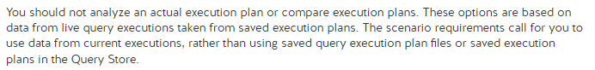

94.

95.

96.

97.

98.

99.

100.

101.

102.

103.

104.

105.

106.

107.

108.

109.

110.

111.

112.

113.

114.

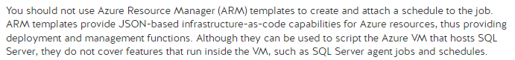

115.

116.

117.

118.

119.

120.

